Practical 6:
Rendering External JSON Data using Fetch API, Search and Filter
Problem Definition:
Display event lists, student profiles, notices, or FAQs from external JSON files using Fetch API. Implement dynamic rendering, search, filter,sorting, and pagination.
Theory :
1. JSON Fetch, Parse, and Render: JSON data is fetched using fetch(), parsed using response.json(), and displayed on the webpage using JavaScript.
2. Array Methods: map() displays data, filter() searches and filters data, sort() sorts data, and slice() is used for pagination.
3. Loading and Error Handling: Loading messages are displayed while fetching data. Errors are handled using catch().
4. JavaScript Modularity: JavaScript code is divided into separate files and functions. export and import are used to share code between files.
Implementation/out put/result:
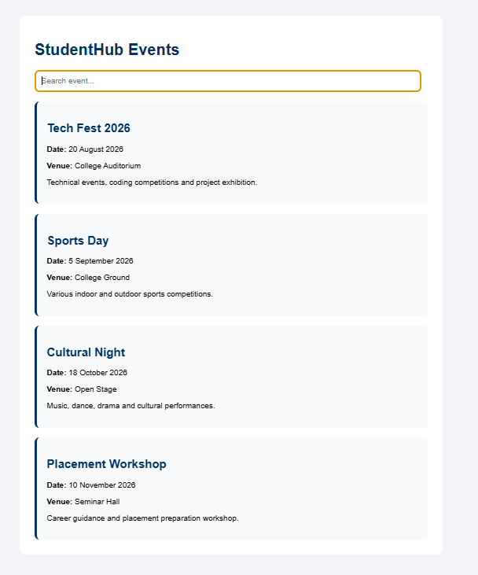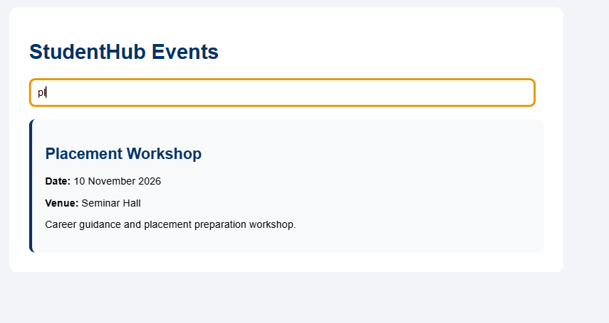

Git hub link:
https://github.com/nidhisavalia/25dce103-web
Learning outcomes:

Learn to fetch and display JSON data using the Fetch API.
Use JavaScript array methods for search, filter, sort, and pagination.
Faculty remarks:

